PHASE VIII
Project Demonstration
Team ID | NM2025TMID39966
Project Name | AI BLOGNEST API

Demonstration Strategy & Execution Overview:
- Prepared a comprehensive, end-to-end live walkthrough strategy to showcase the fully operational capabilities, architectural soundness, and feature completeness of the AI BlogNest API to project evaluators and reviewers.
- Structured the demonstration flow logically—progressing from server initialization and secure environment verification to executing the core functional workflows and verifying external AI service integrations.

Step-by-Step Live Demonstration Walkthrough:
- Server Initialization & Connection Verification:
Demonstrated launching the Node.js backend environment via terminal scripts, highlighting how server.js and app.js successfully load environment variables from .env and establish connection pools through Mongoose to MongoDB instances.

- User Authentication & Authorization Workflow:
Showcased user registration (/api/auth/register) with automatic password hashing via bcrypt, followed by user login (/api/auth/login) generating a signed JWT token. Demonstrated how protected routes reject unauthenticated requests and permit access when valid Bearer tokens are supplied.

- Blog Post & Comment Management Demonstration:
Demonstrated executing full CRUD cycles for blog posts—creating, retrieving, updating, and deleting entries while ensuring strict owner-validation checks. Walked through adding and managing sub-document comments under specific blog articles.

- AI Generation & Summarization Feature Showcase:
Displayed the integration of external AI handlers (aiController.js), executing test prompt requests that dynamically generated structured blog drafts and produced concise text summaries in real-time.

Testing Tool & 5 Core Operations Verification:
Utilized exported Thunder Client request collections (thunder-client-ai-blog...) alongside the environment configuration file (thunder-client-env.json) to execute live API calls during the review, verifying expected JSON responses, status codes, and error-handling behavior.

Specifically highlighted the execution and live response verification of the following 5 key operations:

1)User Registration :
Executing the sign-up endpoint with secure password hashing.
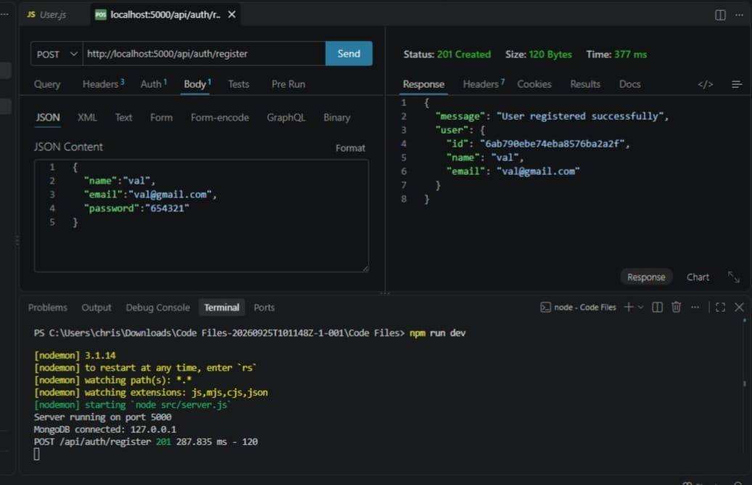

2)User Login :
Authenticating credentials to issue signed JWT access tokens.
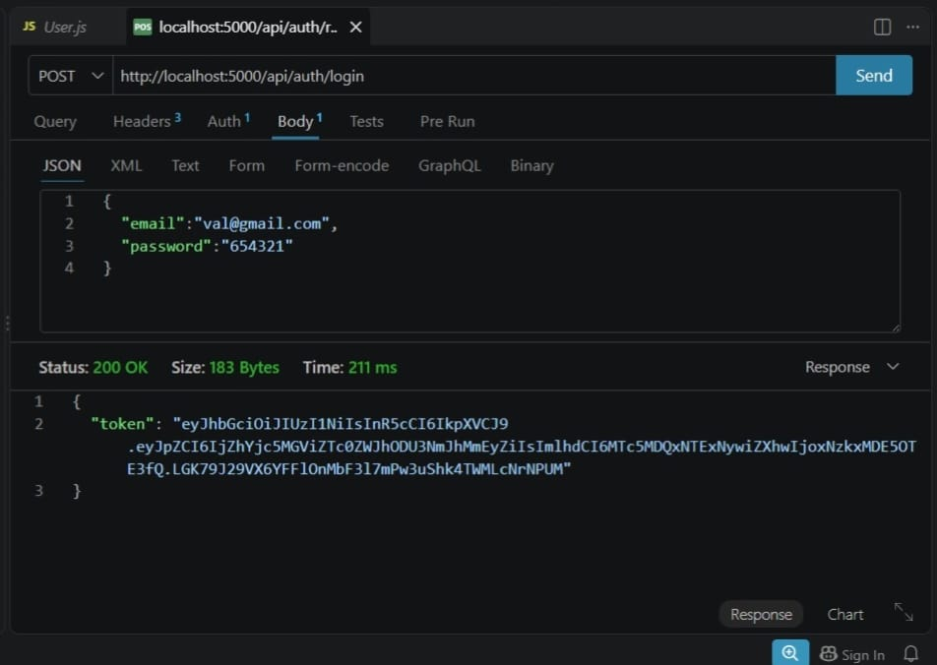

3)Create Blogs:
Submitting authorized requests to publish new blog entries.
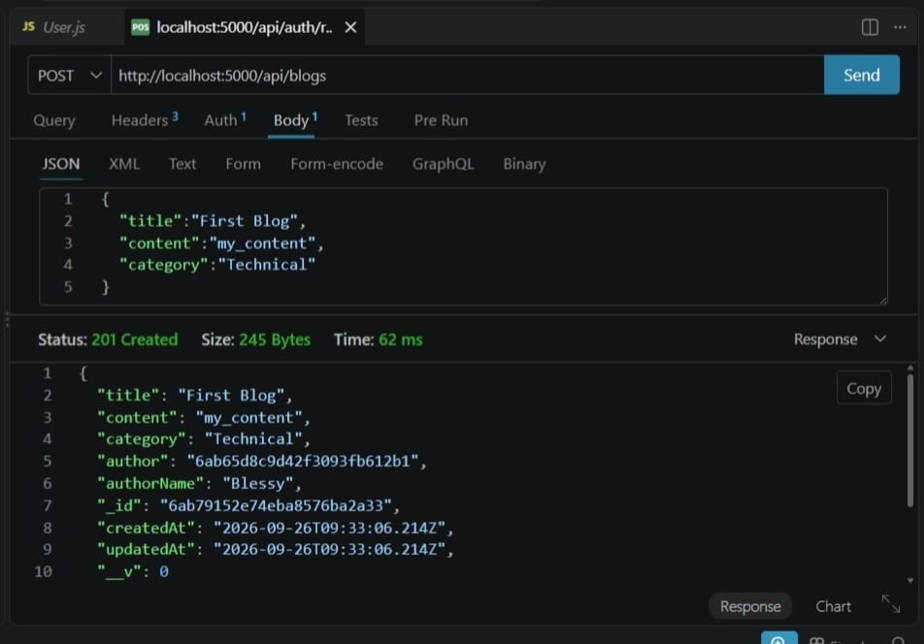

4)Generate Blogs Using AI:
Leveraging external AI integrations to dynamically generate structured blog content from text prompts.

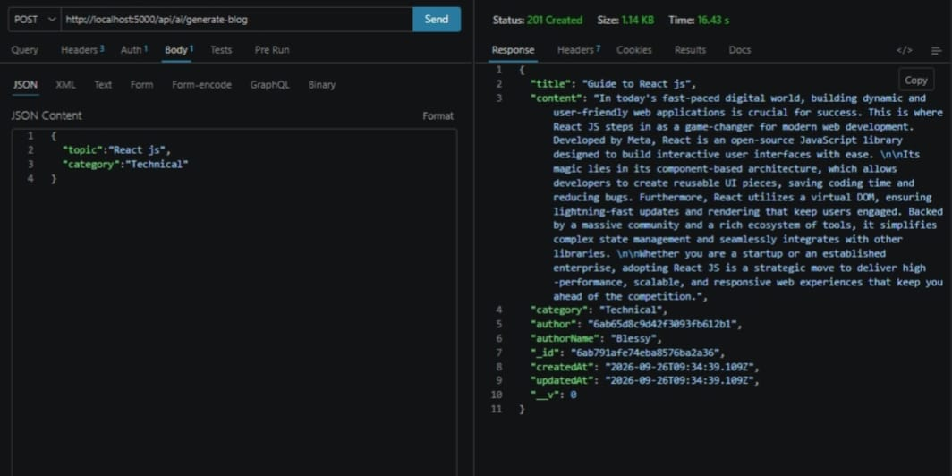

5)Summarize:
Processing long-form text through the AI handler to return automated, concise summaries in real-time JSON format.

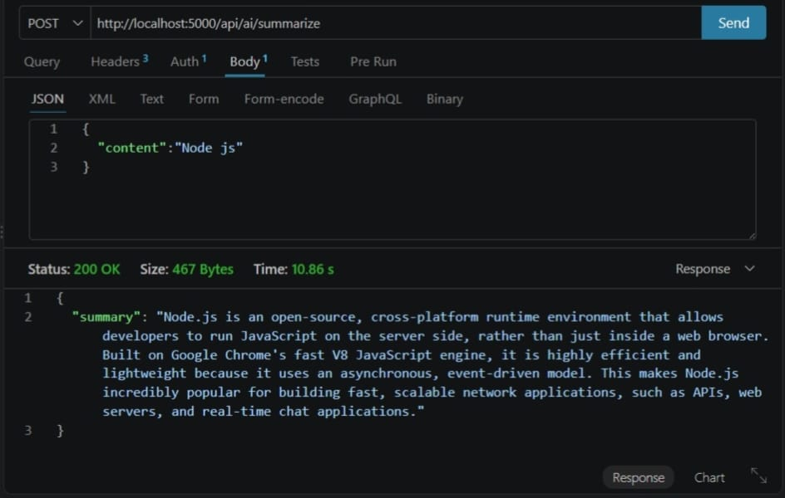

Project Completion & Verification:
All 8 phases of the AI BlogNest API project—spanning architecture design, database modeling, source development, unit testing, documentation, and live demonstration—have been successfully completed, verified, and compiled.

Demo video: Team1 demo vid
API testing: Team1 api testing
Code: code

Sign-Off :
Tester Name: Blessy Valentina D
Date of Completion: 26/09/2026
Signature: Blessy

